I’m thrilled to share a wonderful opportunity for your students to make a difference while gaining valuable experience! Camp Krem, a camp that serves individuals with disabilities, is looking for year-round and summer 2025 Program Counselors. We have two incredible locations: one in the beautiful Santa Cruz Mountains and another near the breathtaking Yosemite.
This would be an incredibly valuable opportunity for students to gain hands-on experience in the fields of Special Education, Healthcare, Human Services, Recreation, and more!
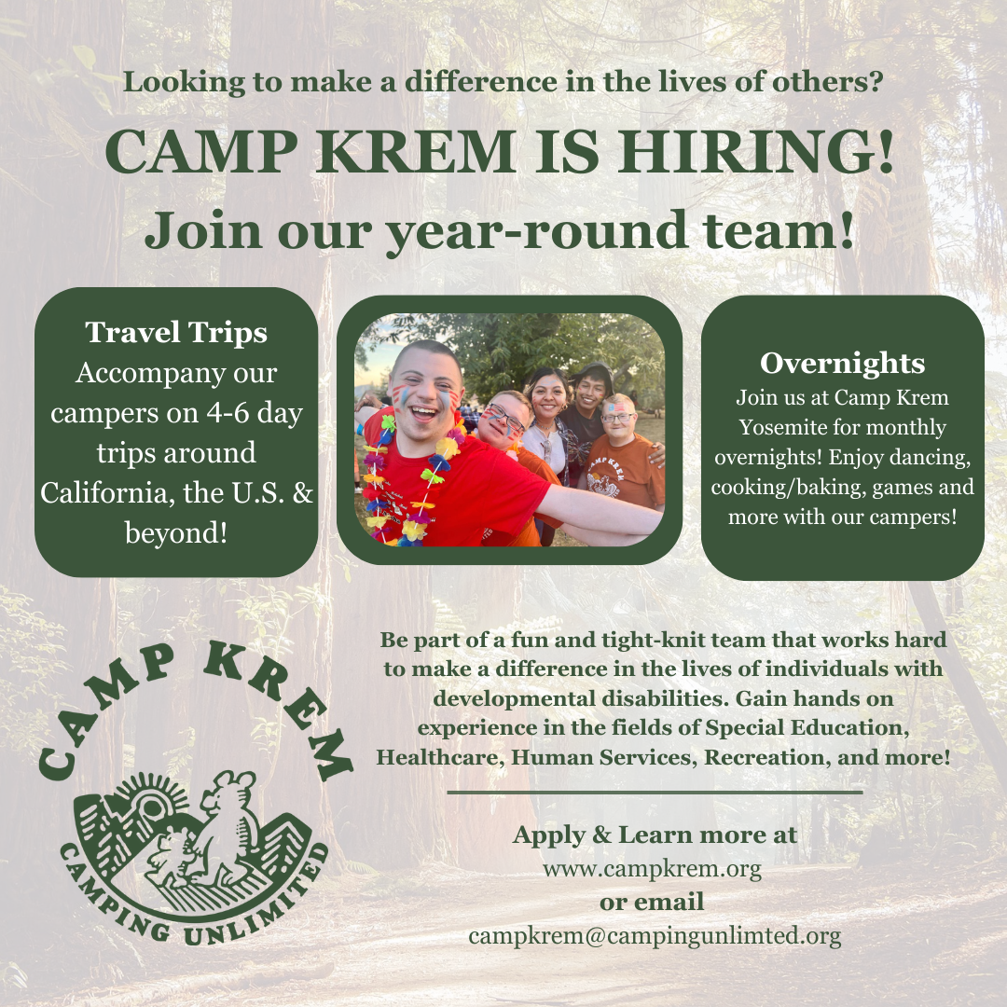
If your students are interested in this enriching experience, they can learn more and apply at www.campkrem.org or reach out to us at campkrem@campingunlimited.org.
Thank you for sharing this opportunity with your students.
Warmly,
Sarah Eicholz
Assistant to the Executive Director

