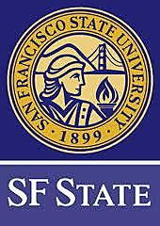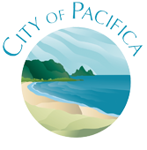

**City of Pacifica - Family Fun Fest**

**Recruiting SF STATE Students Volunteers**

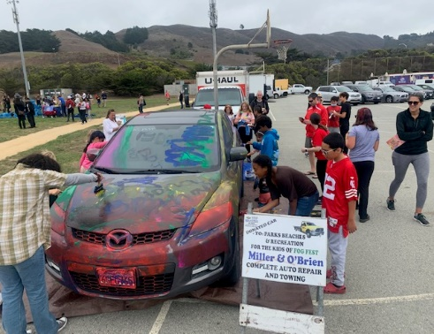City of Pacifica is looking for leaders to facilitate play during this fun annual event. This leadership opportunity includes comprehensive training, resources (on both Sept. 23rd and 24th) practical experience using play, and a lot of fun!

**WHEN IS THE FUN FEST?**

* Sat Sept. 23rd, approx. 12-4pm Training
* Sun Sept. 24th, 9-4:30 Training & Festival

**WHAT IS THE FUN FEST?**

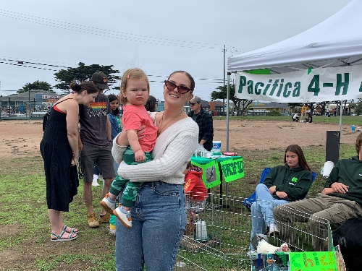The Fun Fest is a free play festival, designed to promote healthy family play, both competitive and cooperative, with an emphasis on participation and a sense of community. A wide variety of peripheral activities (i.e. giant bubbles, , face painting, earth ball, special tot area, decorate-a-car, etc.) as well as many exciting games will be available. Trained volunteers and City of Pacifica Parks, Beaches and Recreation Department employees staff the event. Many local organizations and non-profits will also be participating.

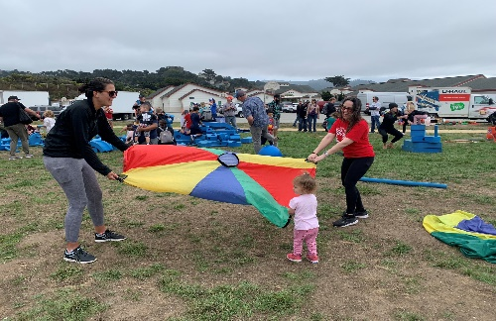Family Fun Fest is a 37-year Pacifica tradition – an afternoon of play, community building, fun and games sponsored by the Pacifica Parks, Beaches and Recreation Department. The Family Fun Fest happens on the last day of the Fog Fest here in Pacifica.

These activities and games provide a new way for people to communicate and interact positively. Games are played simply for the fun of it. There are no prizes to win or opponents to beat - we are playing together!

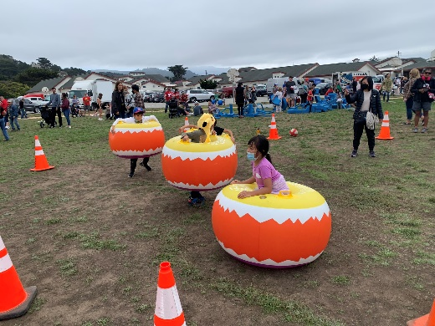**TRAINING:**

The training is a way to develop your skills, prepare for the event and gather a ton of experience/resources on how to lead/play games for all ages and empower the community. The practicum comes Sunday afternoon at the festival.

Training is free for all students and volunteers.

Carpooling and the use of public transportation to get to the training and event is highly encouraged.

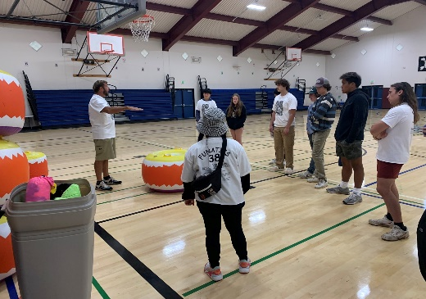**PERKS**

**Professors/Instructors:** Fun Fest training and participation offers an appeal and practical experience for a wide variety of students; those in majors related to Recreation, Community Wellness, Fitness and Kinesiology, and Childhood and Adolescent Development all have something to gain from being trained in community participation and play.

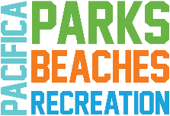**Students/Participants:** Fun Fest T-shirt, snacks on Saturday, and lunch on Sunday. If your department is amenable, your professor/instructor may give class credit/points or build an assignment around participation in the training and festival.